NOC – Distillery

Login : Harinagar-Dis

1. NOC number should start from 1, starting from 7

Retested: Fixed for HPCL_EC and HDD, starting from next serial no.

NOC to be generated in format approved previously . Ref Prohibition bihar link-To be discus with Srinivas sir

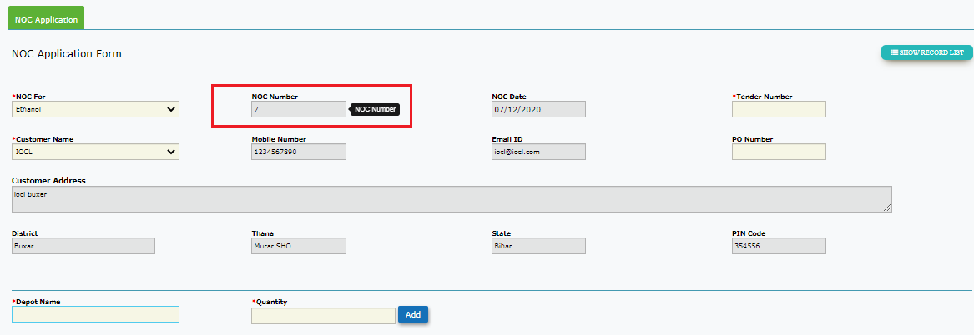

NOC Application List

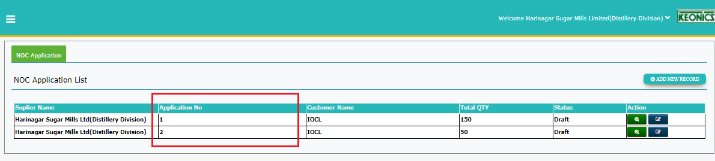

1. Application number is starting from 1 . Are NOC number and application numbers are different.

Expected: IT should be the same.

Retested: Fixed Checked for HPCL_EC and HDD

3 Unable view/ edit the first record getting –

9-Dec-Retested: Reopened. Currently, edit icon is not present

10-Dec-Retested: Fixed Checked HDD

Server Error in '/IEMS_NEW' Application.

*Object reference not set to an instance of an object.*

2 UI- If user does not add the details to GRID and click on save/save as draft the below alert message is displayed. To be changed to “ Please click on ADD button to save the depot details” or as appropriately.-

Retested: Fixed Checked for HPCL_EC and HDD

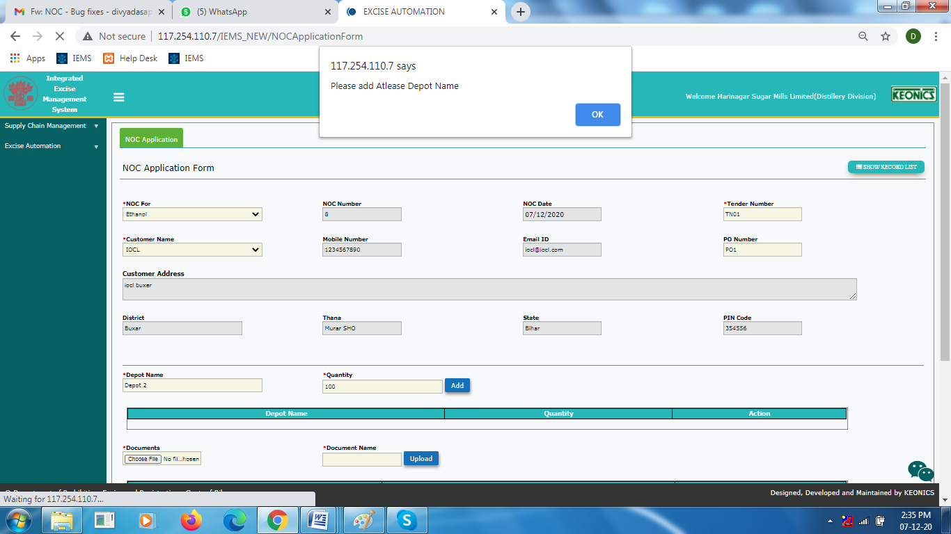

Alert Pop up

UI- “Please Upload atleast one Documents” to be changed to “Please attach documents”

Fixed Checked for HDD

WCEDO login

Wcedo – Rejected the Application – Approver Summary visible to only wcedo. DU cannot see the approval Summary.

Reopened: Even if rejected by asst com, the status still remains as Pending for approval (at both asst com and DU login).---> Reject functionality is not working( Also unable to reapprove the record again) BLOCKER

10-Dec- Checked for HDD-Reopened

Distillery Login

Approver comments not visible to DU(Distillery Unit)

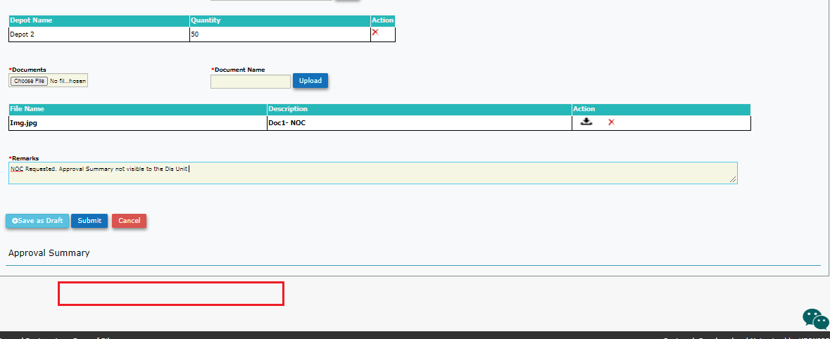

Approval Summary should also be visible to Distillery Unit . But visible after DC rejection

Retested: Fixed Checked for HPCL_EC and HDD

**Hodyco**

Rejected , Status reflected for both AC and DU.

1. Should not be allowed to enter previous dates as “Valid Upto date”
2. Once date is selected – not able to select date from calendar control as it is blank, But user can write manually Expected : dates should be visible in the calendar control

Rejected functionality is not working. Unable to test the 2 points.

10-Dec- Checked for HDD-Reopened

**Distillery Login**

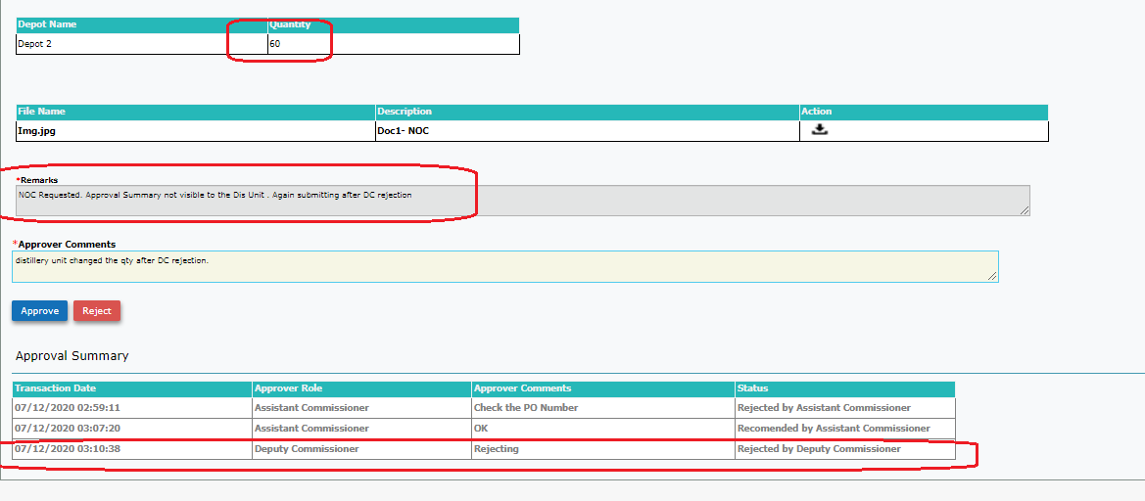Sc1:User changed the submitted NOC details and saved. Saved Details were refelected in levels of approval.

Once application is submitted and passes from AC to DC. Even if DC rejects Distillery Unit should not be allowed to change/ Edit the NOC details entered earlier.Unable to test(Reject func to be fixed)

**Expected:** AS soon as the NOC form is submitted and moved up to the authorities for approval, User should not be allowed to edit. **Submit and Save as draft button should get disabled or invisible**.

Submit or Save as draft button should again get enabled /visible only when AC rejects(Not When DC or Com rejects) . And get disabled once submitted. (TBT- Reject func to be implemented)

10-Dec :Retested: PARTIAL FIX: Checked for HDD , edit option is disabled. Unit cannot edit once submitted.to be checked for scenarios of “reject and refer back”.

**Commissioner Login**

Refer back with comments. Refer Back button working

**DC changes the date and Approved.**

1. But changed date is not reflected in COM login

Unable to test-- Refer back func not working

**10-DEC-TBT- Will be retested when blocker is removed. (See page 5)**

**Ref below the approval summary for more details**

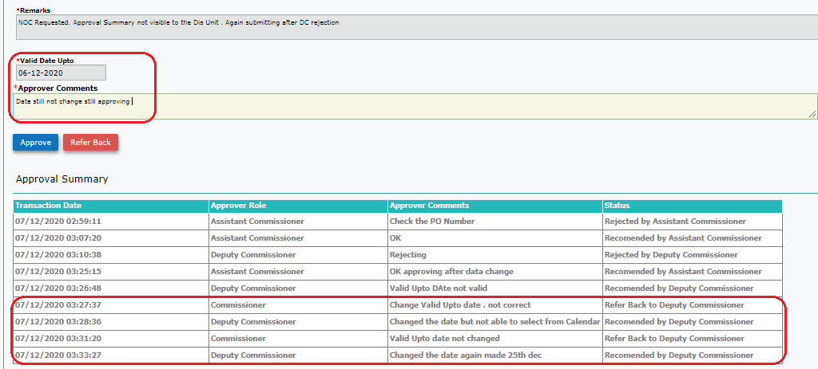

Hodyco - Issue

Issued and Print

When printed the NOC issued. Report is blank with only format and no data.

Retested: Fixed

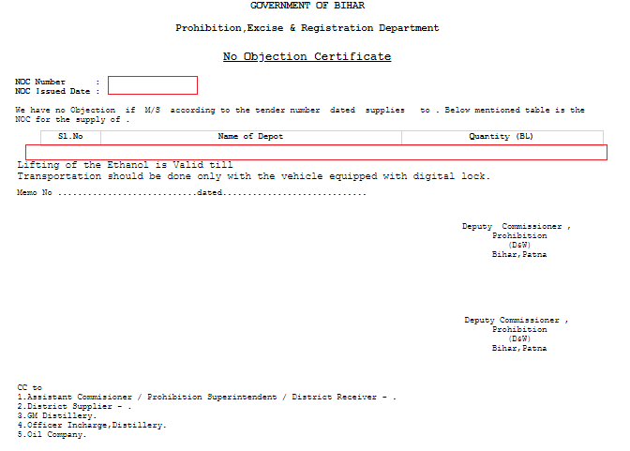

Date : 08-Dec

To be tested when Blocker is removed

1. Noc submitted by DU**- Wcedo**- Entering remarks and “Reject” – Not working
2. Recommended by wcedo – **Hodyco login** – Refer back to wcedo – Not working

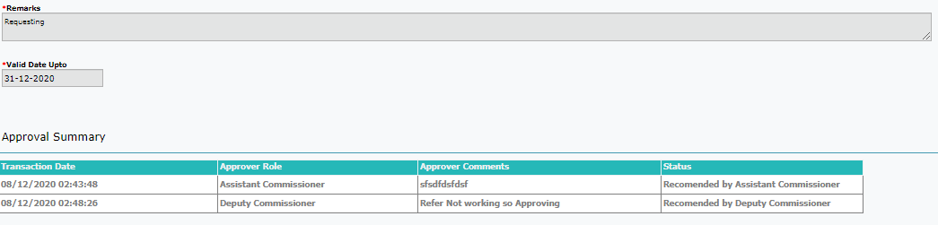

1. Recommended by hodyco – **Com login**- Refer Back to hodyco – Not Working
2. So Trying to approve – Not working getting the below error **- BLOCKER**

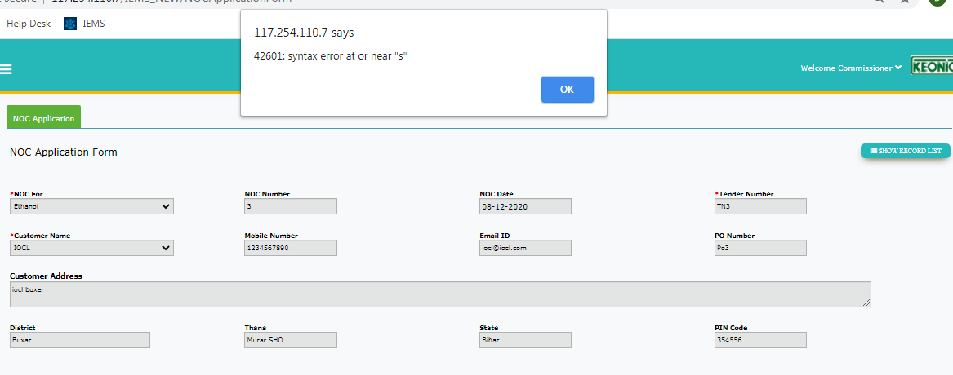

10-Dec- Findings

Login :HDD

1. Wcedo – Reject” function Not working
2. Hodyco - Approve button ,valid upto date selection , Remarks and approval Summary Missing- BLOCKER

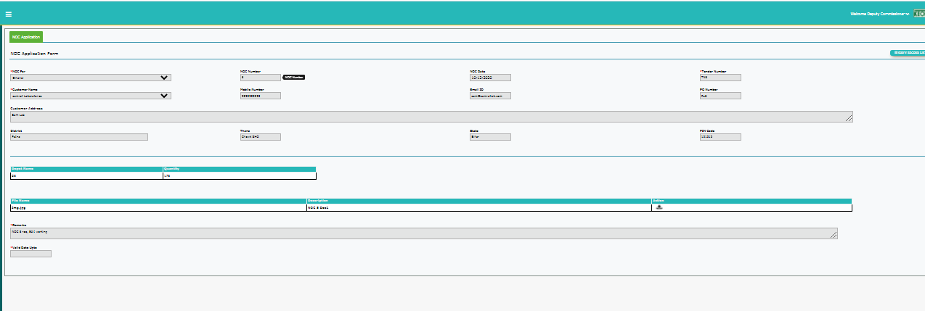

Print for already issued NoC- Data is fetched with below findings

1. Format of Date  and  are different.

Content to be rephrased.

1. Depot Details are repeated

